

International School

API Design & Integration Document
Course: System Integration Practices
Project Title: Integrated HR & Payroll Dashboard System for Company X
Case Study: 3–4 (Backend API Development & Security Integration)
Version: 1.0
Date: 15/4/2026
Group: Group 5
Semester: 2 – Academic Year 2025–2026
Instructor: MSc. Nguyen Dang Quang Huy
Team Members:
Name | Student ID
Manh, Nguyen Van Duy | 29211100024
Loc, Tran Viet | 29211352994
Tin, Huynh Tran | 29211358847
Loi, Tran Van | 29211159367
Viet, Dang Dai | 29211155820

Approved by
MSc Huy, Nguyen Dang Quang

Da Nang 05/2025
Project Acronym | HRD
Project Title | Company X – Integrated HR & Payroll Management Dashboard
Start Date | 17 April 2026 | End Date | 20 May 2026
Lead Institution | International School, Duy Tan University
Role | Name | Email |  | Phone
Project Mentor | Nguyen Dang Quang Huy | huyndq@duytan.edu.vn |  | 0935525354
 | Nguyen Van Duy Manh | duymanhdnvn1@gmail.com |  | 0779534325
 | Tran Viet Loc | tranvietloc288@gmail.com |  | 0365957050
 | Huynh Tran Tin | trantin202ad@gmail.com |  | 0899565751
 | Tran Van Loi | tvl19012005@gmail.com |  | 0898238541
 | Dang Dai Viet | vdang9721@gmail.com |  | 0384165721

DOCUMENT NAME
Document Title | API Design & Integration Document
Reporting Period | 17– April - 2026
Author(s) | Tran Viet Loc
Role | Developer
Date | 17/04/2026 | File name | 5. API Design & Integration Document (IEEE 1016).docx

DOCUMENT APPROVALS
Document Approvals: The following signatures are required for approval of this document.
Mentor | Huy, Nguyen Dang Quang | Signature:
 |  | Date:
 |  | Date:
Team member(s) | Manh, Nguyen Van Duy | Signature:
 |  | Date:
 | Loc, Tran Viet | Signature:
 |  | Date:
 | Tin, Huynh Tran | Signature:
 |  | Date:
 | Loi, Tran Van | Signature:
 |  | Date:
 | Viet, Dang Dai | Signature:
 |  | Date:

TABLE OF CONTENTS
1. Introduction 6
1.1 Purpose of the Document 6
1.2 Scope 6
1.3 References 7
2. System Overview 7
2.1 System Context 7
2.2 Architecture Overview 7
3. API Design Specification 8
3.1 API Naming Convention 8
3.2 Authentication & Authorization 8
4. API Endpoint Specifications 9
5. Data Synchronization Logic 11
5.1 Synchronization Scenarios (Reconciliation) 11
5.2 Transaction Logging (Audit Trail) 12
6. Error Handling & Logging 12
7. Integration and Deployment 13
7.1 API Gateway & Security 13
7.2 Environment Setup 14
8. Testing and Validation 14
8.1 Unit Testing (pytest) 14
8.2 Integration Audit Script (integration_audit.py) 14
9. Appendix 15

1. Introduction

1.1 Purpose of the Document

This document describes in detail the API design and software integration architecture for the 'Integrated HR & Payroll Dashboard System' project. The APIs built serve as Middleware connecting the Frontend (React/Vite) with two core databases: HUMAN_2025 (SQL Server) and PAYROLL_2026 (MySQL).

This document is intended for the development team (Backend/Frontend Developers), testers, and the supervising instructor to clearly understand the API structure, security model, and the actual synchronization/reconciliation logic being implemented.

1.2 Scope
The API integration scope includes:
- Authentication (Auth): Manage user registration, login, and sessions (Session Token) through an independent database (SQLite).
- HR Integration: Discover schema and retrieve personnel data from the SQL Server system.
- Payroll Integration: Discover schema and retrieve salary data from the MySQL system.
- Dashboard & Reconciliation: Provide APIs for 360-degree employee data aggregation, connection status checking, data quality assessment, and reconciliation to identify discrepancies between HR and Payroll.

Note: The current version focuses on Read-Only Sync (data reconciliation) to protect the integrity of the original databases. Write operations (CRUD) are routed through an internal transaction log mechanism.

1.3 References

IEEE Std 1016-2009 – Software Design Description
IEEE Std 830-1998 – Software Requirements Specification
Case Study 3 & 4 Documents (System Integration Practices, 2025)
Flask RESTful / ASP.NET Web API Documentation (2024)
JWT Authentication Standard (RFC 7519)

2. System Overview

2.1 System Context
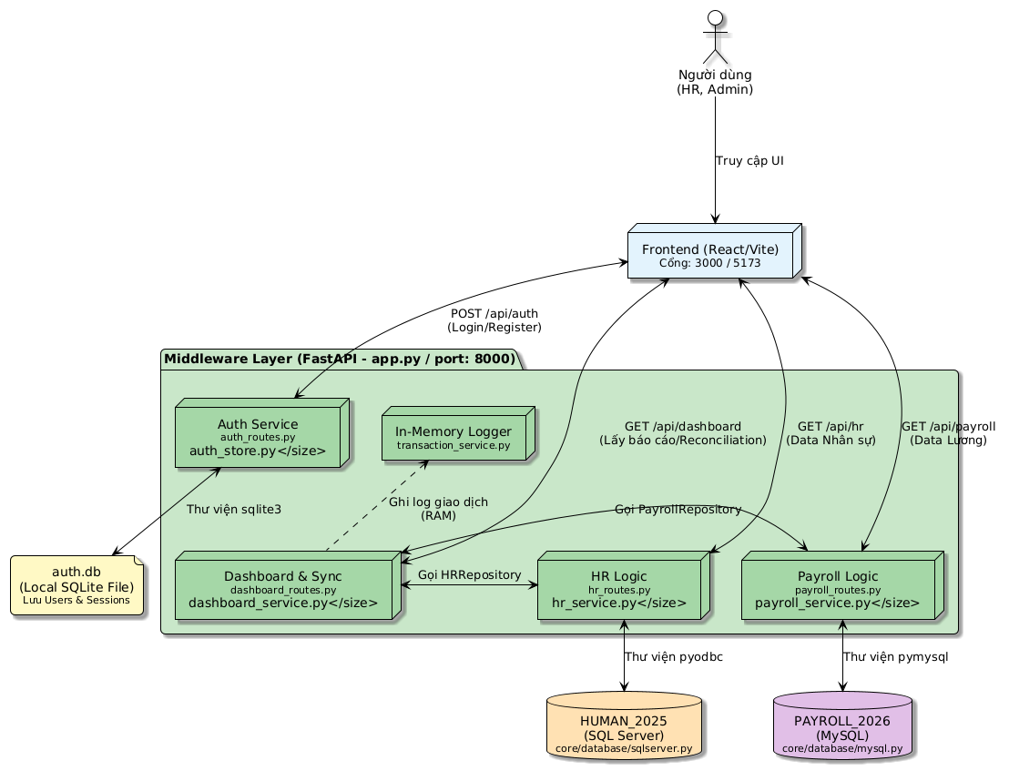

2.2 Architecture Overview
The system strictly adheres to 3-Tier Architecture, clearly reflected in the source code directory structure:
- Presentation Layer (api/): Defines FastAPI Routers (auth_routes.py, dashboard_routes.py, hr_routes.py, payroll_routes.py). Receives HTTP requests, validates parameters, and returns JSON.
- Business Logic Layer (services/): Contains core logic. Includes dashboard_service.py (aggregates data from both sides), sync_service.py (compares schema/rows), and transaction_service.py (stores transaction traces in-memory).
- Data Access Layer (repositories/ & core/database/): Manages Connection Pool, safely executes SQL queries to SQL Server, MySQL, and handles opening/closing connections.

3. API Design Specification

3.1 API Naming Convention
Base URL: http://localhost:8000/api/
Convention: Use lowercase nouns separated by hyphens (kebab-case).
Group prefixes:
- /auth/*: User authentication.
- /dashboard/*: Data aggregation APIs for the Dashboard.
- /hr/*: Communication with SQL Server.
- /payroll/*: Communication with MySQL.

3.2 Authentication & Authorization

The system uses Token-based Authentication stored in an independent SQLite database, without interfering with SQL Server/MySQL.

Authentication Flow:
- User calls POST /api/auth/login with username/password.
- System hashes the password (SHA-256 + Salt) and matches it in the users table.
- If correct, generates a Session Token (secrets.token_hex(32)) stored in the sessions table (valid for 24 hours) and returns it to the client.
- Client sends this Token in the Query Parameter (?token=...) or Header for subsequent requests.

Authorization: The role field in SQLite (default: viewer). Extended for Role-Based Access Control (RBAC) in the next phase.

4. API Endpoint Specifications

No. | Endpoint | Method | Description | Request Parameters | Response (Success) | Auth
1 | /health | GET | Check system status and both databases | None | { "status": "ok", "databases": {...} } | 1
2 | /api/auth/register | POST | Register a system account | username, email, password, confirm | HTTP 200 - User ID and info | 2
3 | /api/auth/login | POST | Login to obtain a Token | username, password | { "token": "<hex_string>", "user": {...} } | 3
4 | /api/auth/me | GET | Get current user information | ?token=<hex_string> | User Info Object | 4
5 | /api/dashboard/status | GET | SQL Server & MySQL connection status | None | { "sqlserver": {...}, "mysql": {...} } | 5
6 | /api/dashboard/overview | GET | Get table count overview from both DBs | None | { "hr": {...}, "payroll": {...} } | 6
7 | /api/dashboard/reconciliation | GET | Reconcile data: find employees in HR but not in Payroll and vice versa | None | { "summary": {...}, "missing_in_payroll": [...], ...} | 7
8 | /api/dashboard/employee/{id} | GET | Employee 360 View: Merge HR & Payroll data for one employee | Path: employee_id | { "hr": {...}, "payroll": {...} } | 8
9 | /api/hr/schema | GET | Discover table structure of HUMAN_2025 | None | Schema JSON Object | 9
10 | /api/payroll/schema | GET | Discover table structure of PAYROLL_2026 | None | Schema JSON Object | 10

5. Data Synchronization Logic

5.1 Synchronization Scenarios (Reconciliation)
The system does not blindly overwrite data but performs a scan to identify data gaps:

Scenario 1: New employee with no payroll record:
- API calls get_all_employees() from HR Repository and get_all_employees_payroll() from Payroll Repository.
- Converts to Dictionary (Hash map) based on EmployeeID.
- Finds EmployeeIDs that exist in hr_dict but not in payroll_dict. Adds them to the missing_in_payroll list.

Scenario 2: Orphaned payroll data:
- Finds EmployeeIDs that exist in Payroll but not in HR. Adds them to the missing_in_hr list.

The Dashboard will call /api/dashboard/reconciliation to display this error list for the HR Manager to address.

5.2 Transaction Logging (Audit Trail)
All read/write operations passing through the Middleware are tracked via TransactionService.
- Workflow: Transactions are stored in the temporary in-memory _transaction_log (maximum 1000 records).
- Data stored: action (READ/WRITE), target_db (HUMAN_2025/PAYROLL), table, timestamp. This helps admins monitor who is accessing which system.

6. Error Handling & Logging
Error Code | Description | Example Response
400 | Bad Request | Invalid input data (e.g., password and confirm_password do not match during Registration).
401 | Unauthorized | Wrong Username/Password when logging in; Token expired when calling /api/auth/me.
404 | Not Found | Employee 360 API called but employee information not found (raise HTTPException(status_code=404)).
500 | Internal Server Error | pyodbc/pymysql connection error, SQL query error.

Logging:
- Log format: %(asctime)s │ %(levelname)-8s │ %(name)s │ %(message)s
- Logs DB connection errors to Console: ❌ MySQL connection failed: ... or ✅ SQL Server connected.

7. Integration and Deployment

7.1 API Gateway & Security
The integration system uses multi-layer security architecture and safe routing through an API Gateway placed in front of the application.

1. API Gateway (Routing & Load Balancing):
- Deployment tool: Nginx configured as a Reverse Proxy / API Gateway to receive external requests.
- Routing: Nginx receives requests from the Frontend and routes /api/* paths to the ASGI server (Uvicorn) running FastAPI internally on port 8000 (or 8001).
- Load Balancing: When the volume of HR and Payroll data reconciliation requests increases, Nginx can distribute the load evenly across multiple FastAPI workers.

2. Security Rules:
- HTTPS Enforced: Nginx manages the SSL/TLS certificate, enforcing that all communication between the Dashboard (Client) and API Layer is encrypted via HTTPS to prevent salary data eavesdropping.
- JWT & Session Validation: Handled by FastAPI Middleware. All data requests must include a valid Token generated from auth_store.py (SQLite). Middleware validates the token before querying SQL Server or MySQL.
- CORS Protection: CORSMiddleware configuration in app.py blocks unknown domains, allowing only valid origins to access resources (e.g., http://localhost:3000 and http://localhost:5173).

7.2 Environment Setup
The system uses environment variables (.env file) managed via pydantic_settings to separate configuration for different environments, ensuring database credentials are not exposed in the source code (GitHub).
Environment | Purpose | Key Variables
Local | Development | DEBUG=true, PORT=8000, MYSQL_HOST=127.0.0.1
Test | Integration Testing (Run audit test) | Same as Local, using test script integration_audit.py.
Production | Deployment (Production operation) | DEBUG=false, Change SQLSERVER_HOST and MYSQL_HOST to the actual Database Server IPs.

8. Testing and Validation

8.1 Unit Testing (pytest)
Uses pytest and httpx libraries to test Async endpoints.
Notable test cases in the code:
- test_health.py: Tests the /health endpoint to check if it returns the correct format for both databases.
- test_auth.py: Runs a simulated flow: Register fake User (uuid) → Login → Get token → Check Me → Logout → Re-check for 401 error.
- test_transaction_service.py: Tests the In-memory audit log.

8.2 Integration Audit Script (integration_audit.py)
- Uses the requests library to run a real End-to-End scenario in the test environment (port 8000).
- Scenario: Register → Login → Get Token → Call a series of Dashboard APIs (/schema, /status, /overview, /reconciliation, /quality) → Display [PASS] / [FAIL] results in the terminal.

9. Appendix
A. Glossary
Term | Meaning
FastAPI | Python Web Framework used to build APIs.
Reconciliation | The process of comparing and cross-referencing data between two databases to identify discrepancies.
pyodbc / pymysql | Libraries for connecting to SQL Server and MySQL databases in Python.
B. References
IEEE 1016 – Software Design Description (2009)
Case Study 3–4 Requirements (System Integration Practices, 2026)
Flask RESTful / ASP.NET Core Documentation (2024)
OWASP API Security Top 10 (2024)

